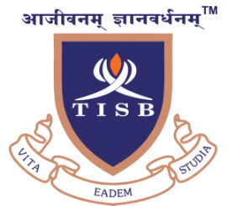
THE INTERNATIONAL SCHOOL BANGALORE (TISB), INDIA (www.tisb.org)
College Counselor
The International School Bangalore is the premier coeducational HMC day and boarding school in India. For August 2018 (or sooner, if possible) we require a dynamic, able and experienced Counselor to assist our Head of College Counselling with the smooth operation of the department and the College Counseling Office.
The successful applicant will have a comprehensive understanding of international tertiary educational opportunities, a proven track record of success in the field of international university placement, relevant management experience and a passion for excellence.
The candidate will have extensive knowledge of current best practice and will have outstanding inter-personal skills. They will have an openness to the complexities and demands of a multicultural Indian setting and the ability to work independently and collaborate with a team. A highly competitive salary that compares well to western rates will be paid and will be commensurate with experience. The successful applicant will be expected to contribute to the life of a thriving boarding school and will be entitled accommodation on campus if they wish.
Please send a letter of application, together with curriculum vitae, including the contact details of three professional referees to school@tisb.ac.in marked FAO Mr. Peter Armstrong, Principal.

